Helmitin Adhesive
& Swift Prime
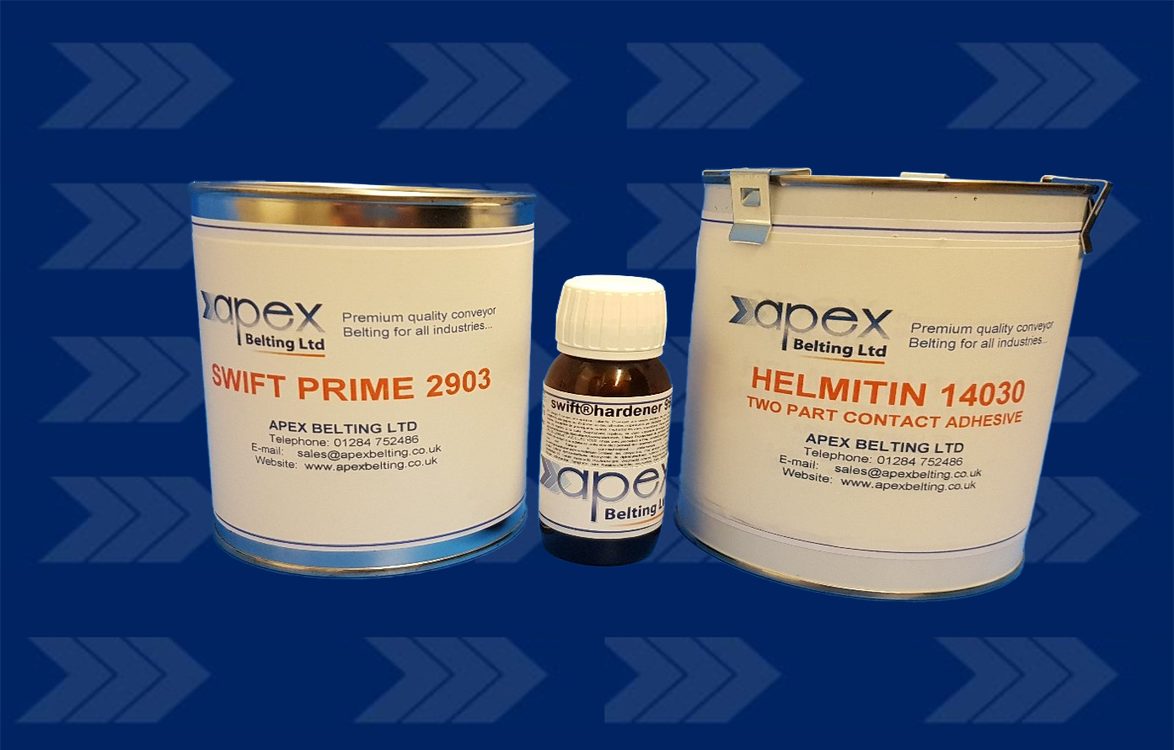
We are the UK distributor for Helmitin adhesive, a 2-component contact adhesive for joining and repairing conveyor belts, lining steel containers and applying rubber coating to steel-rollers.
Our Swift Prime adhesive is a solvent-based primer, ideal for bare metal, particularly steel , used in preparation for bonding rubber.
24/7 Emergency Servicing & Repairs

